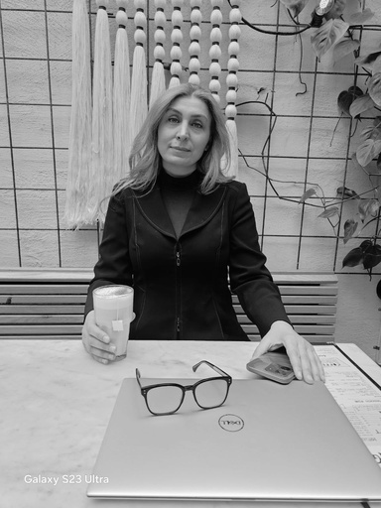 | Mina Tahmasebi Berjouei S O F T W A R E D E V E L O P E R A N D A I E N G I N E E R  PROFILE
SKILLS  ---- | EDUCATION  CHALMERS UNIVERSITY OF TECHNOLOGY
M.Sc. in Information and Communication Technology
- 2025 - ungoing
Advanced machine learning with neural networks
Advanced Software Engineering for AI/ML-Enabled Systems Design of AI systems
Introduction to data science and AI
Advanced probabilistic machine learning
Probability and statistical learning using Python
YRKESHÖGSKOLAN CAMPUS MÖLNDAL
LANGUAGES  - Swedish: Fluent  - English: Fluent  - Persian: Native | Cloud Development  - 2023 - 2025
 |  | Object-oriented architecture and programming in C#
 |  | Cloud development using Azure, AWS, and GCP with Kubernetes and ARM
 | templates
CONTACT  Mobile: +46 79 202 4105  mina_tb@outlook.com  Seminariegatan 8, 41313 Gothenburg, Sweden  LinkedIn: mina-tahmasebi GitHub: mina-mtb | NBI HANDELSAKADEMIN  Object-Oriented System Development  - 2019 - 2021
 |  | Object-oriented programming, analysis, and design
 |  | Database management and web application development
Kaggel: minatahmasebi
IRAN UNIVERSITY
REFERENSER Bachelor's in Software Engineering and Computer Science
- 2000 - 2007
References available upon request

WORK EXPERIENCE
ASTRAZENECA — POWER PLATFORM ASSISTANT / JUNIOR POWER PLATFORM EXPERT
January 2025 – June 2025 | Gothenburg, Sweden
- Developed and supported the "Training Analysis (Feedback)" solution using Power Apps, Power Automate, Dataverse, and Power BI
- Analyzed and optimized business processes through automation and low-code solutions
STAR REPUBLIC AB (SQLI) — SYSTEM DEVELOPER
January 2022 – April 2022 | Gothenburg, Sweden
- Contributed to the InRiver project, a large-scale enterprise PIM system with extensive third-party integrations
- Integrated the platform with multiple e-commerce systems using Azure Service Bus and integration channels
- Designed, developed, and maintained integration services to ensure reliable data flow and system synchronization
SIGMA TECHNOLOGY GROUP — SOFTWARE DEVELOPER
2020 – 2021 | Gothenburg, Sweden
- Developed backend services for the "Giving People" mobile application
- Designed and implemented RESTful APIs using .NET, SQL Server, and Entity Framework
GOTHENBURG CITY — SUBSTITUTE ASSISTANT NURSE/ EXTRA & SUMMER JOB
June 2022 – NOW | Gothenburg, Sweden
I work as a substitute assistant nurse alongside my studies and during the summer. I am registered with several different elderly care homes and work where there is a need for staff when I am available. I have experience working in both somatic care and dementia care. My duties also include medication handling through delegation. I currently work mainly as night staff, but I also have experience working day shifts.
ETEHAD BUILDING PRODUCTS — SALES AND MARKETING MANAGER
2009 – 2015 / Iran
Managed sales and marketing for a large national wholesaler of building materials and pipes
Led a team of 8 staff responsible for customer acquisition, sales follow-up, and client relationships
Worked with customers across different cities, including construction material shops, retailers, and business clients
Supported large orders, negotiations, and government tender opportunities
Developed sales strategies to expand the customer base and increase sales performance
ABLOLE POLYETHYLENE FACTORY — MARKETING AND SALES REPRESENTATIVE
2007 – 2009 / Iran
Identified and contacted potential new customers for polyethylene products
Presented the company’s products and explained their value to prospective clients
Persuaded new customers to place their first orders and start cooperation with the company
Handed over new customers to the sales department for continued order handling and follow-up
Focused on customer acquisition, lead generation, and opening new business relationships

